# **58. Wireless Configuration**

## **Topology Introduction**

### **Internal PC (VLAN 100) Accessing Default Gateway via Internal CAPWAP Tunnel**

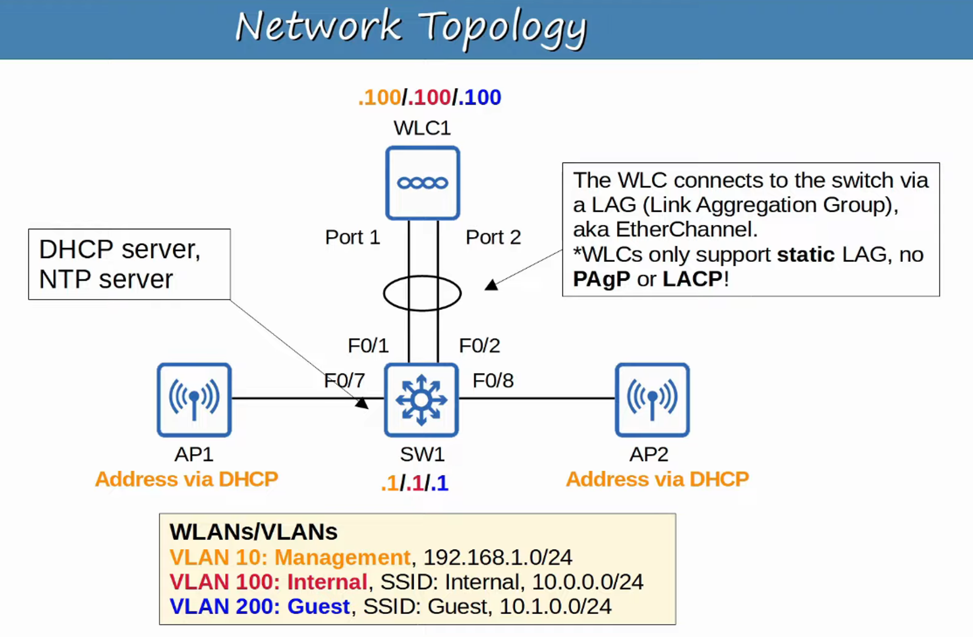

### **Reaching External Guest PC via Default Gateway + Internal and External CAPWAP Tunnels**

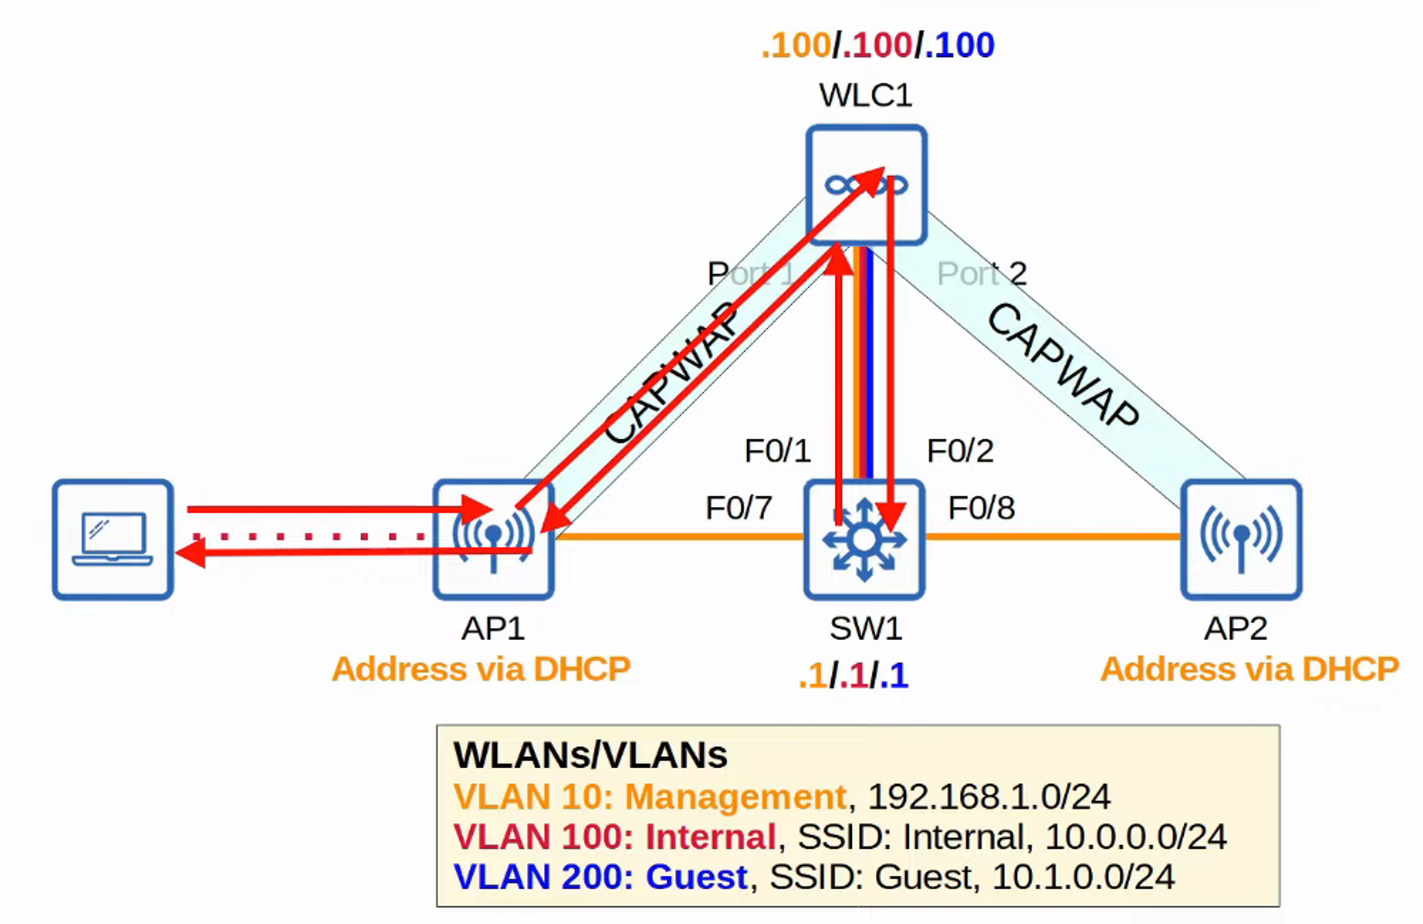

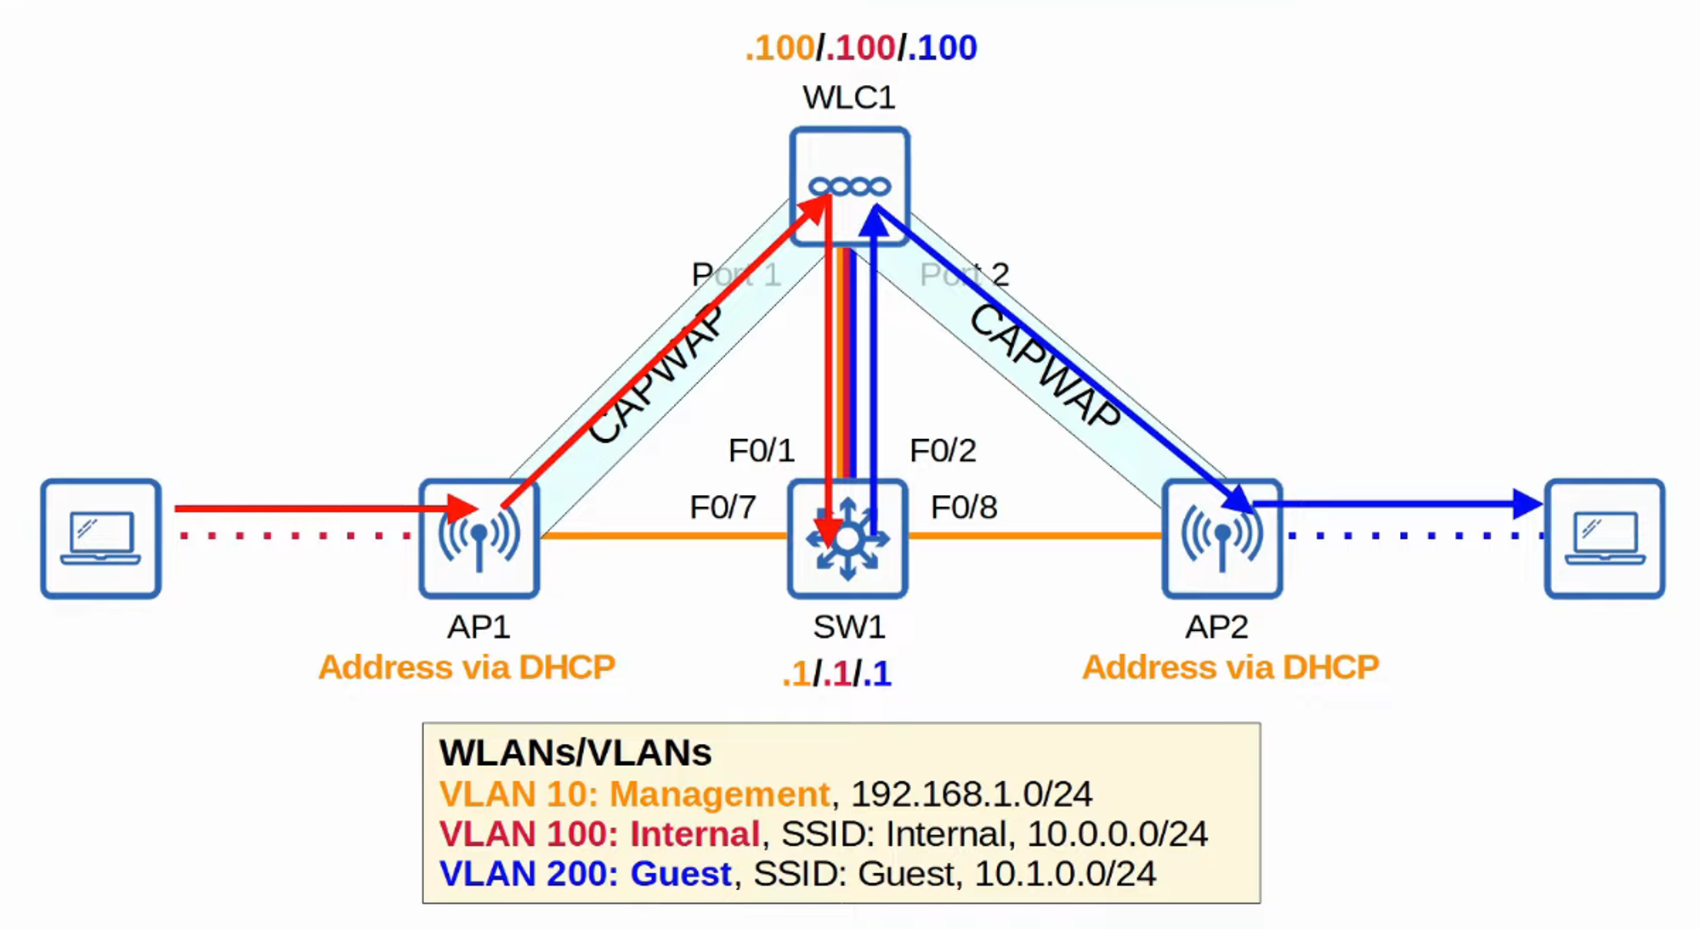

## **Layer 3 Switch Configuration (SW1)**

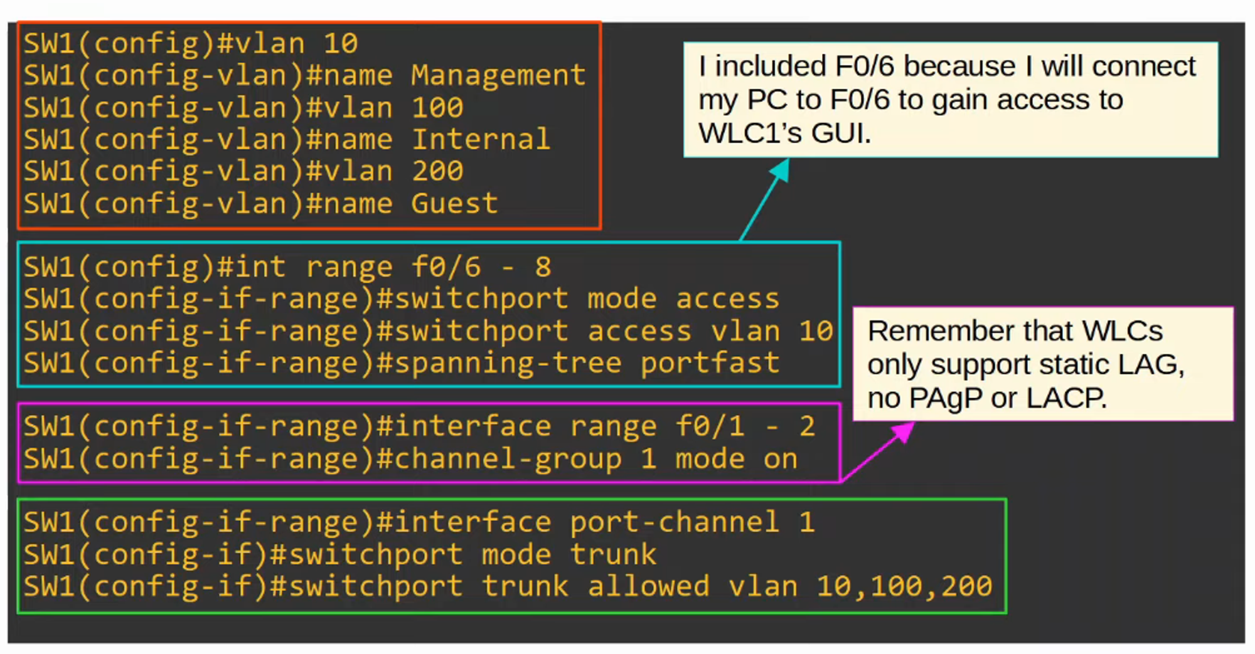

### **Part 2 of Configuration**

Note: DHCP "Option 43" 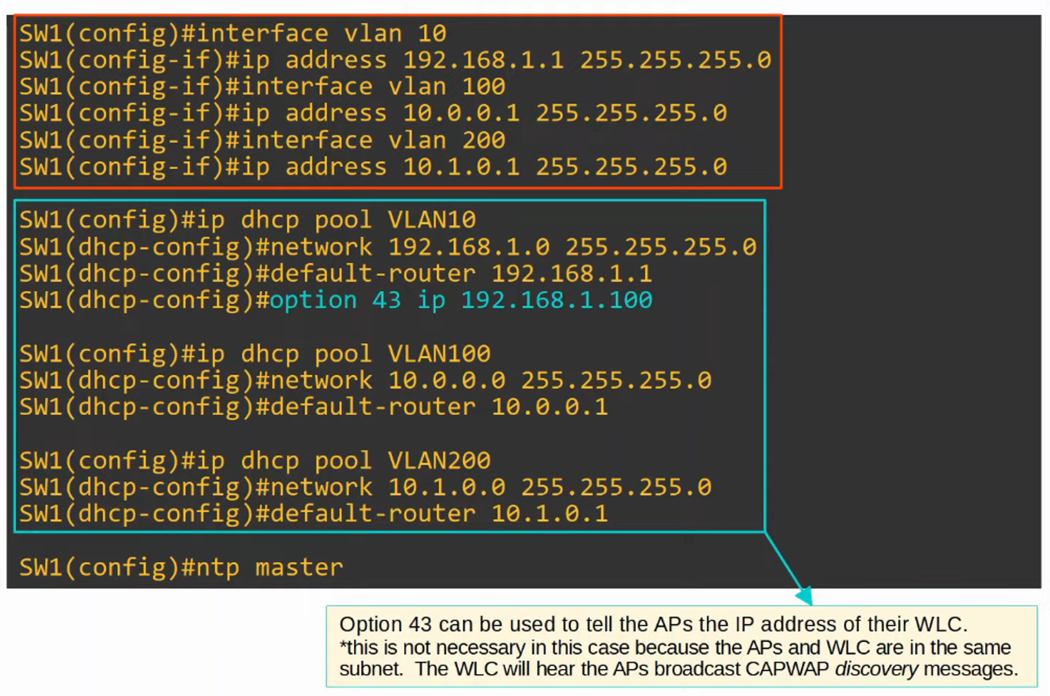

## **WLC Setup**

This setup allows for GUI configuration. 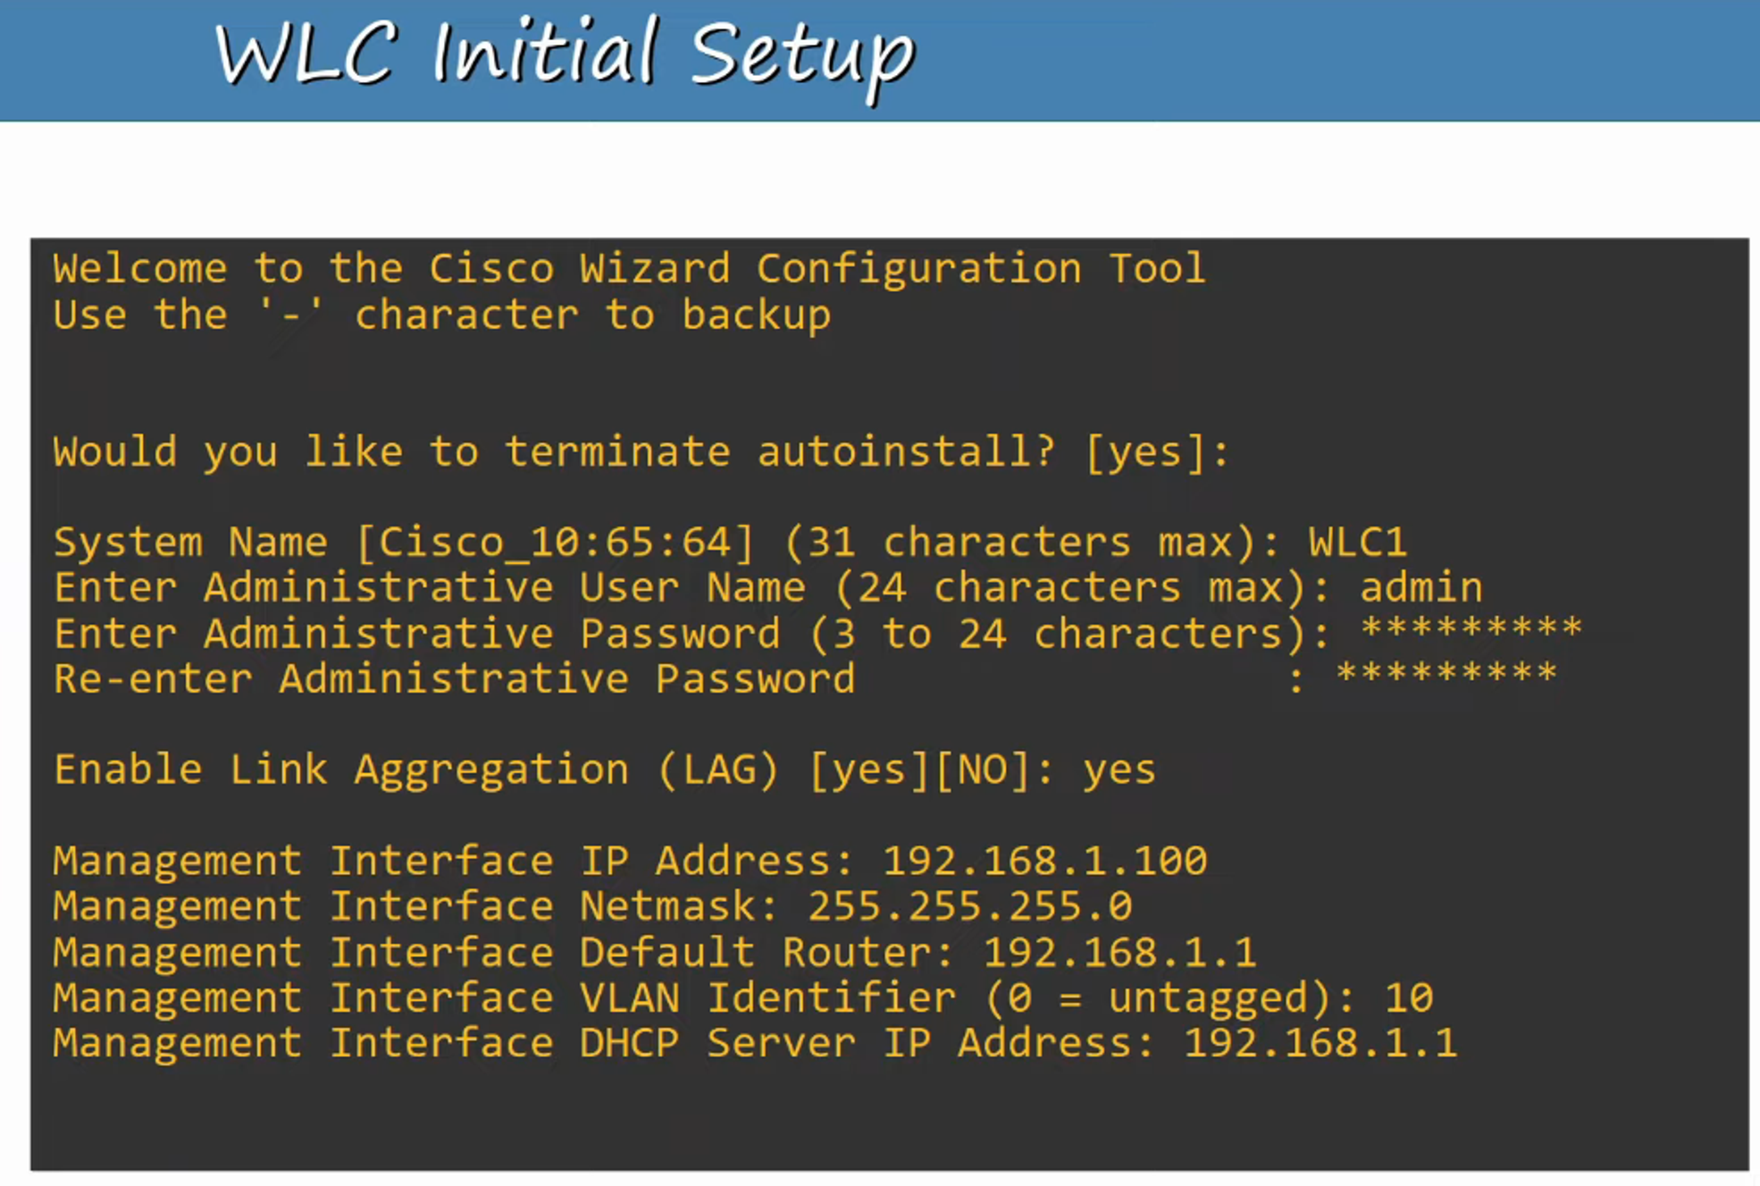

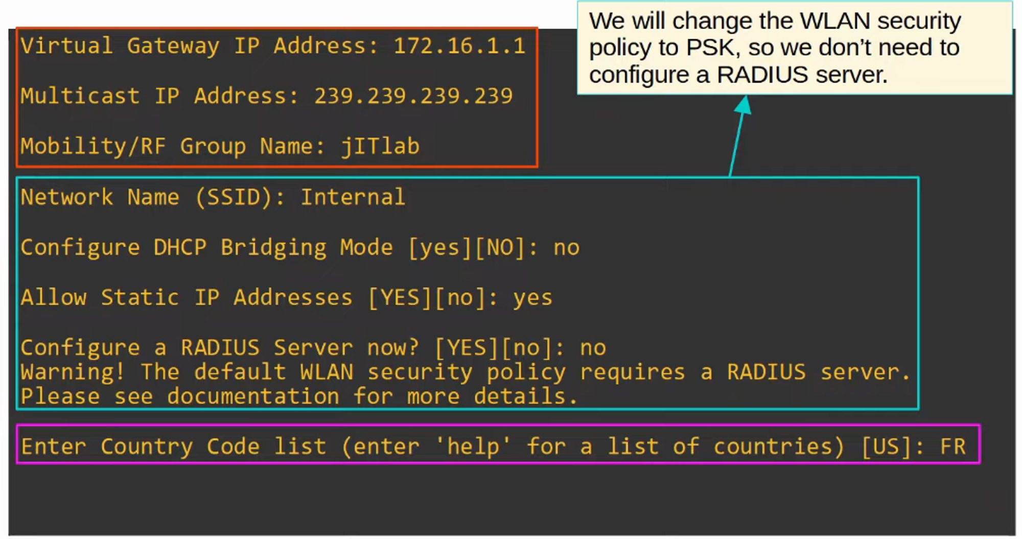

### **Why Jeremy Chose France for Country Code**

This decision is related to the regulatory domain of the equipment. 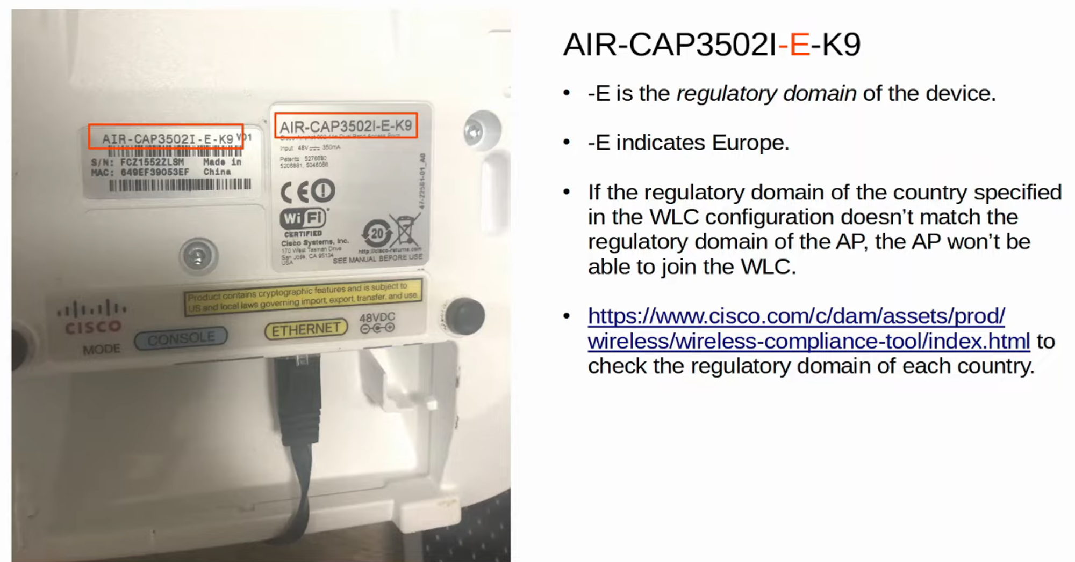

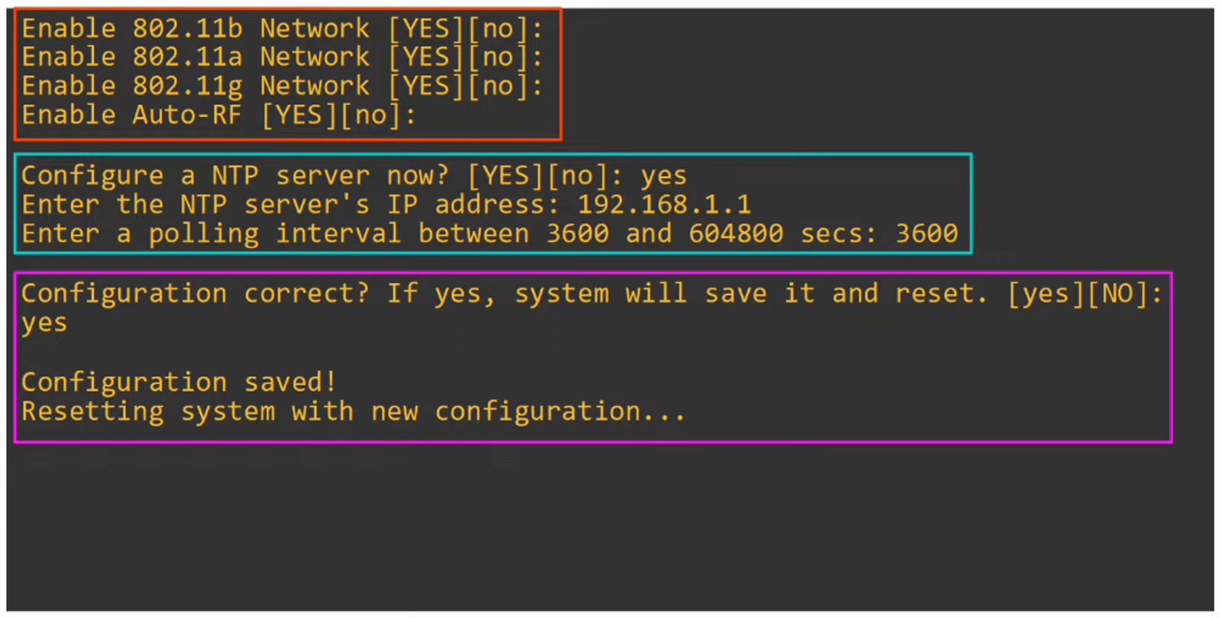

## **Accessing the WLC GUI**

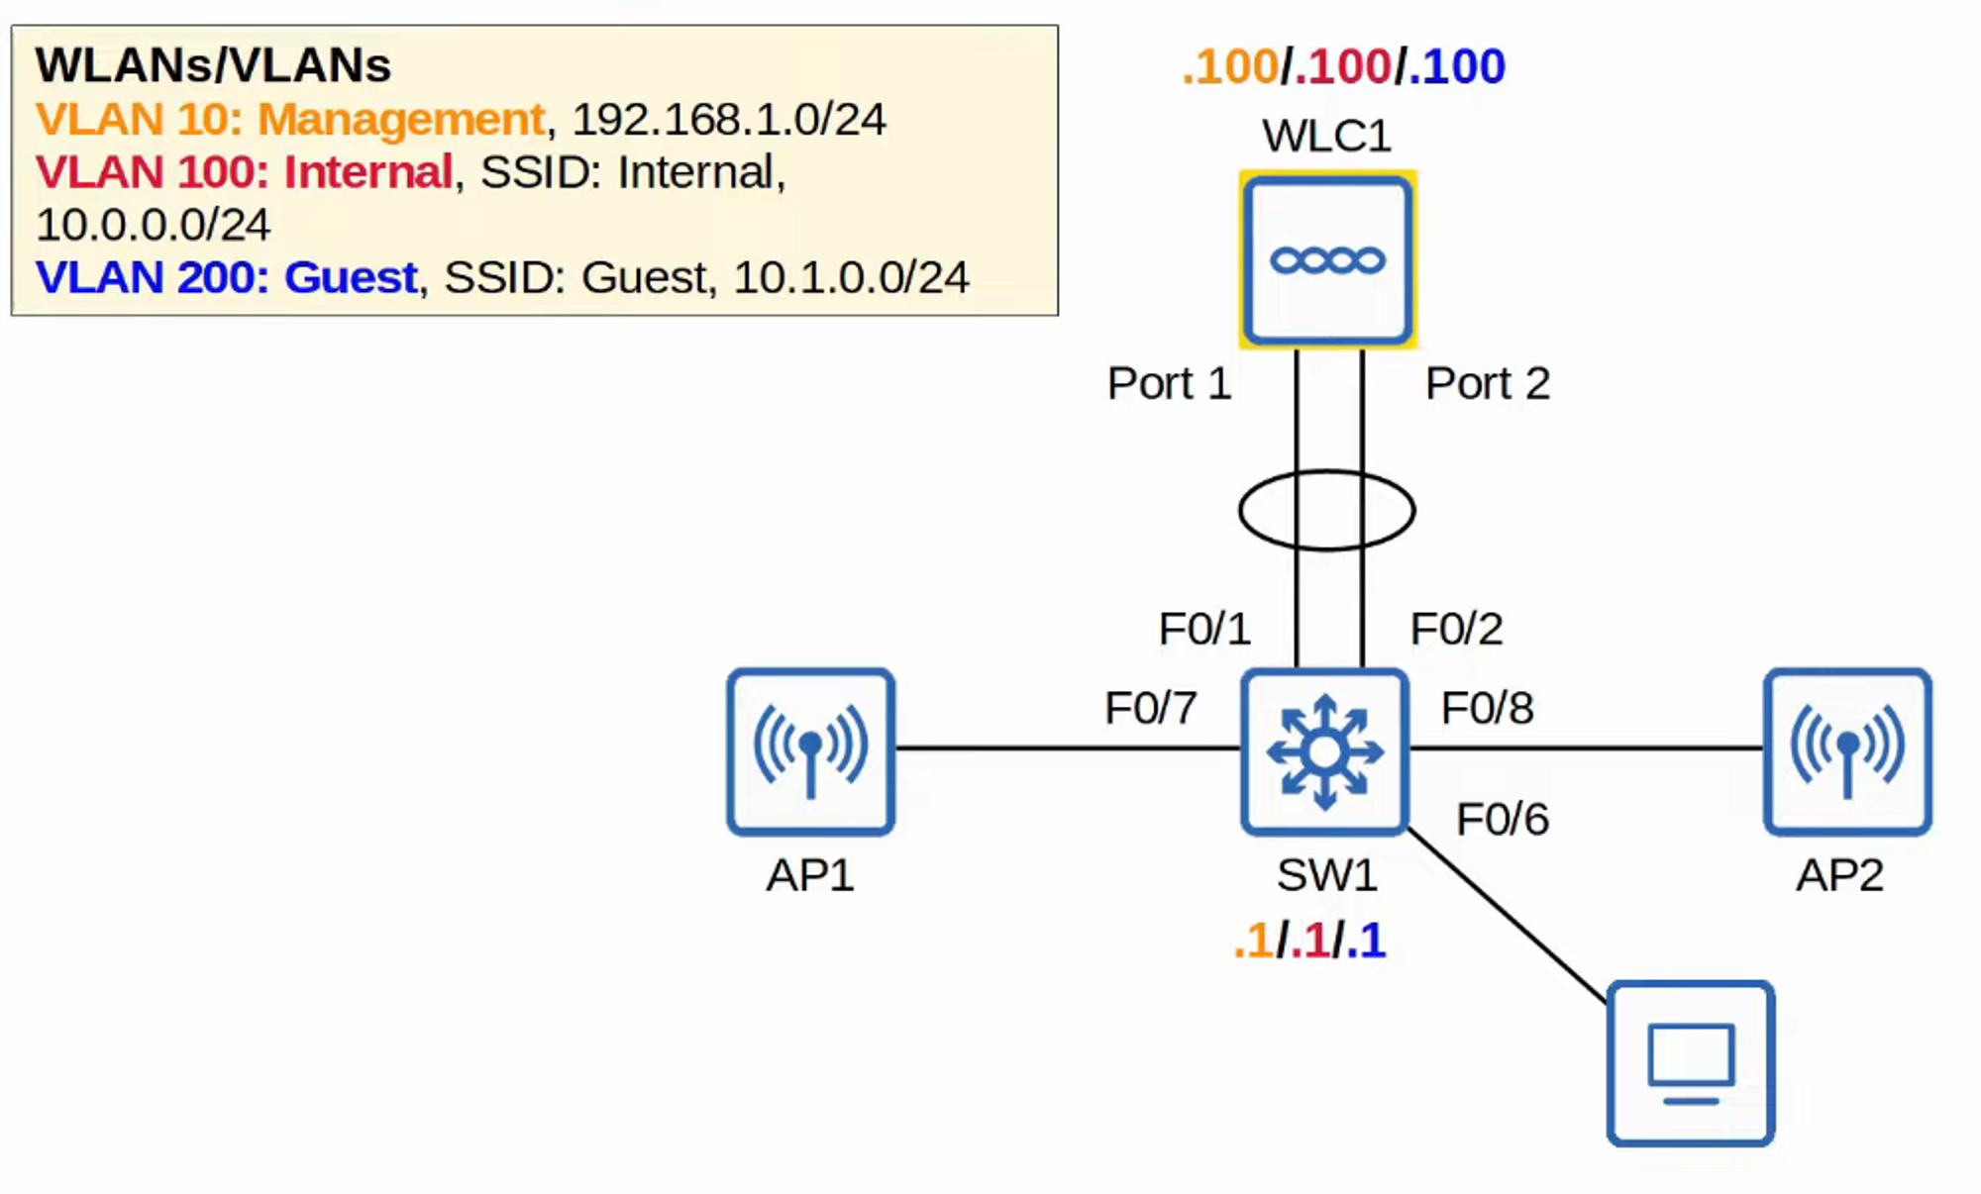

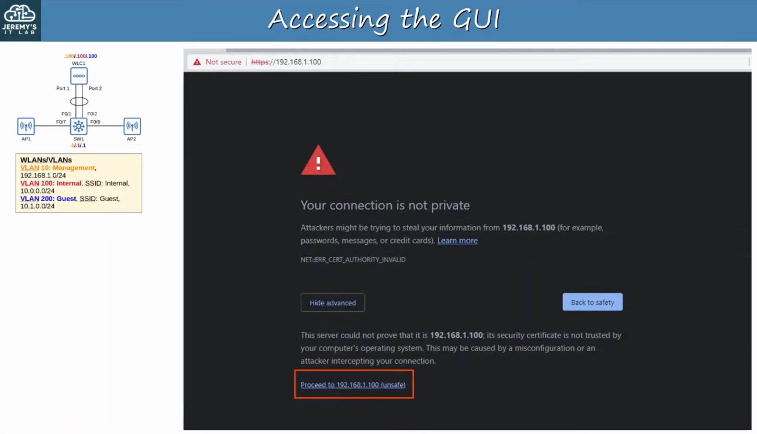

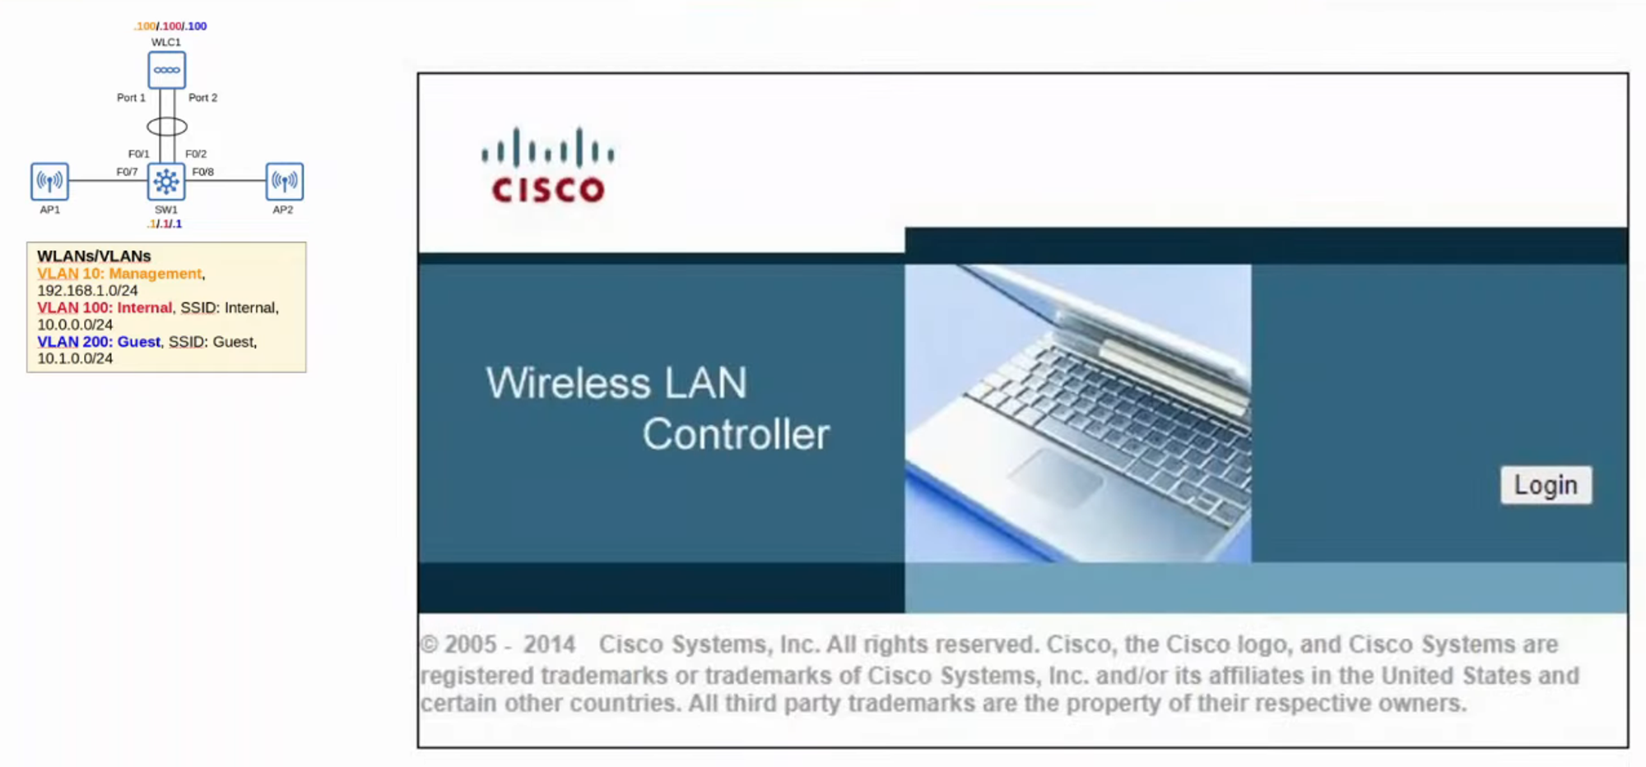

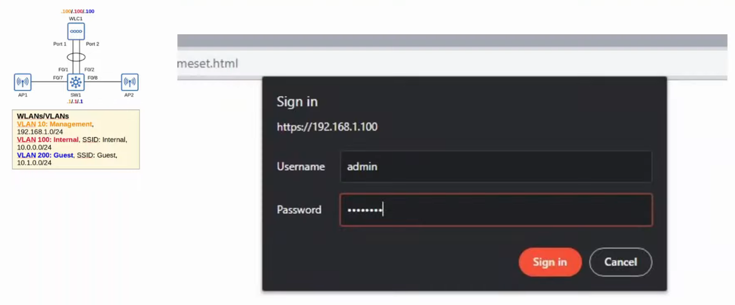

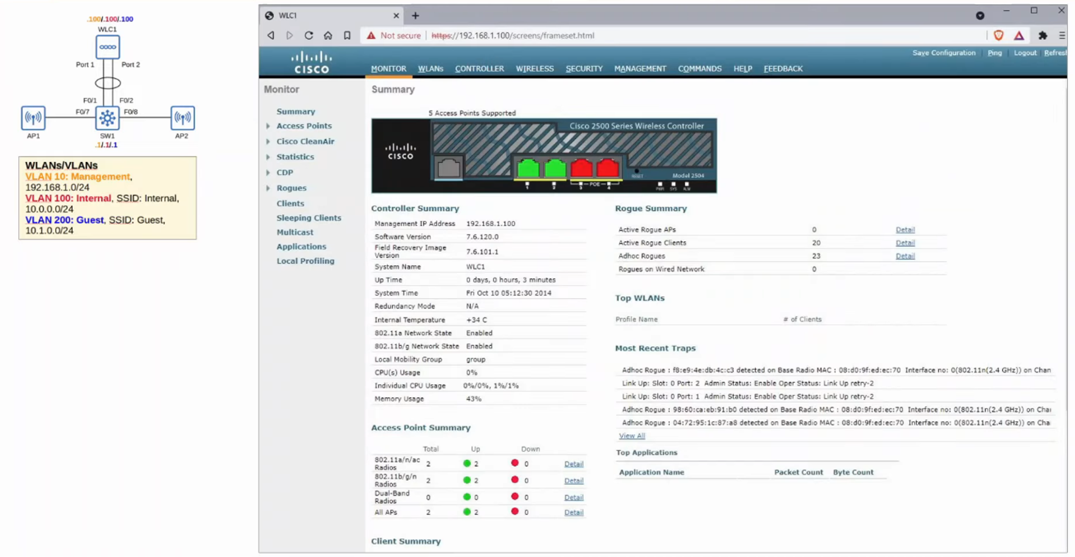

## **WLC Configuration**

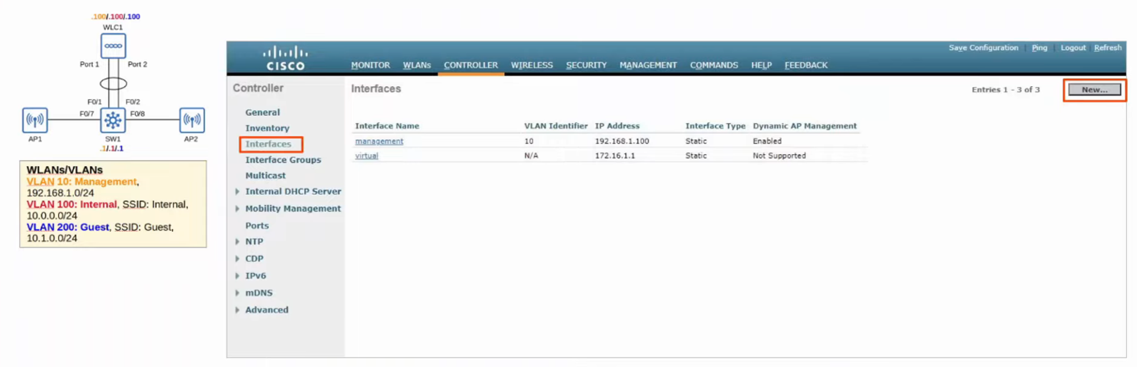

### **WLC Ports**

* **Service Port**: Used for out-of-band management.
* **Distribution System Port**: Connects to wired network.
* **Console Port**: Standard console connection (RJ45/USB).
* **Redundancy Port**: Connects to another WLC for HA.

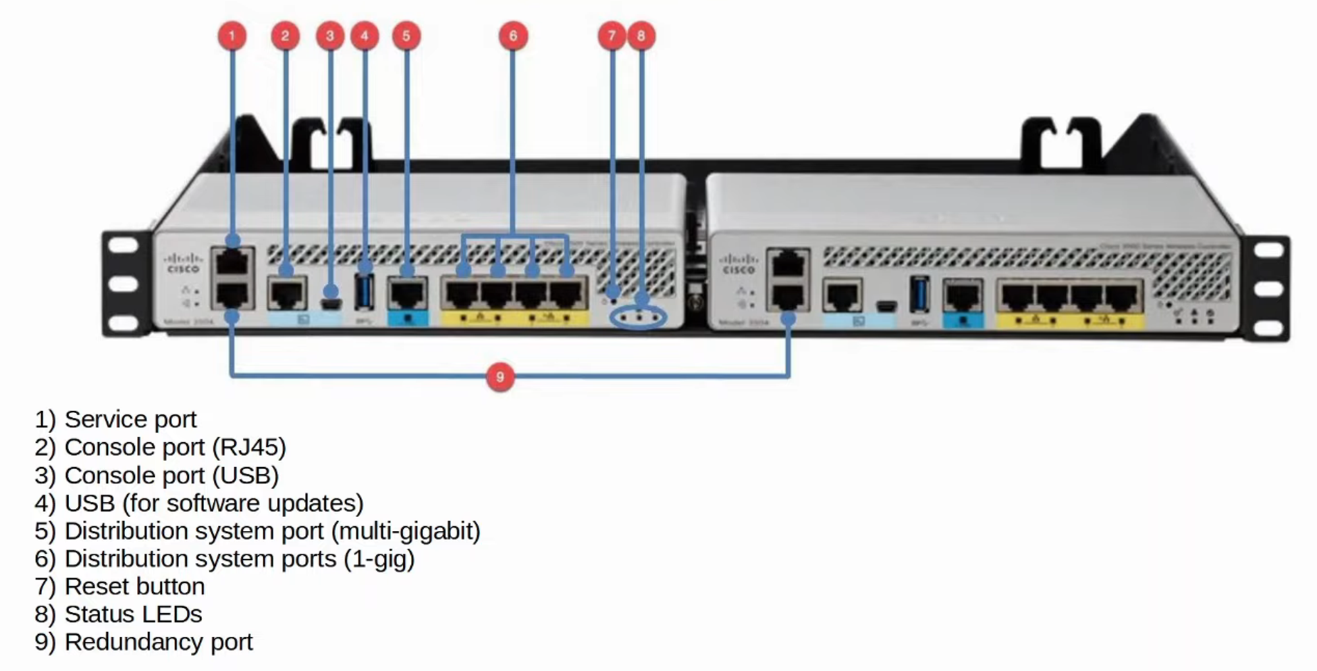

### **WLC Interfaces**

* **Management Interface**: Handles management traffic.
* **Redundancy Management Interface**: Used for standby WLC management.
* **Virtual Interface**: Used for DHCP relay and web authentication.
* **Service Port Interface**: Used for out-of-band management.
* **Dynamic Interface**: Maps WLAN to VLAN.

## **WLAN Configuration**

### **Creating a New WLAN**

Click **"NEW"** 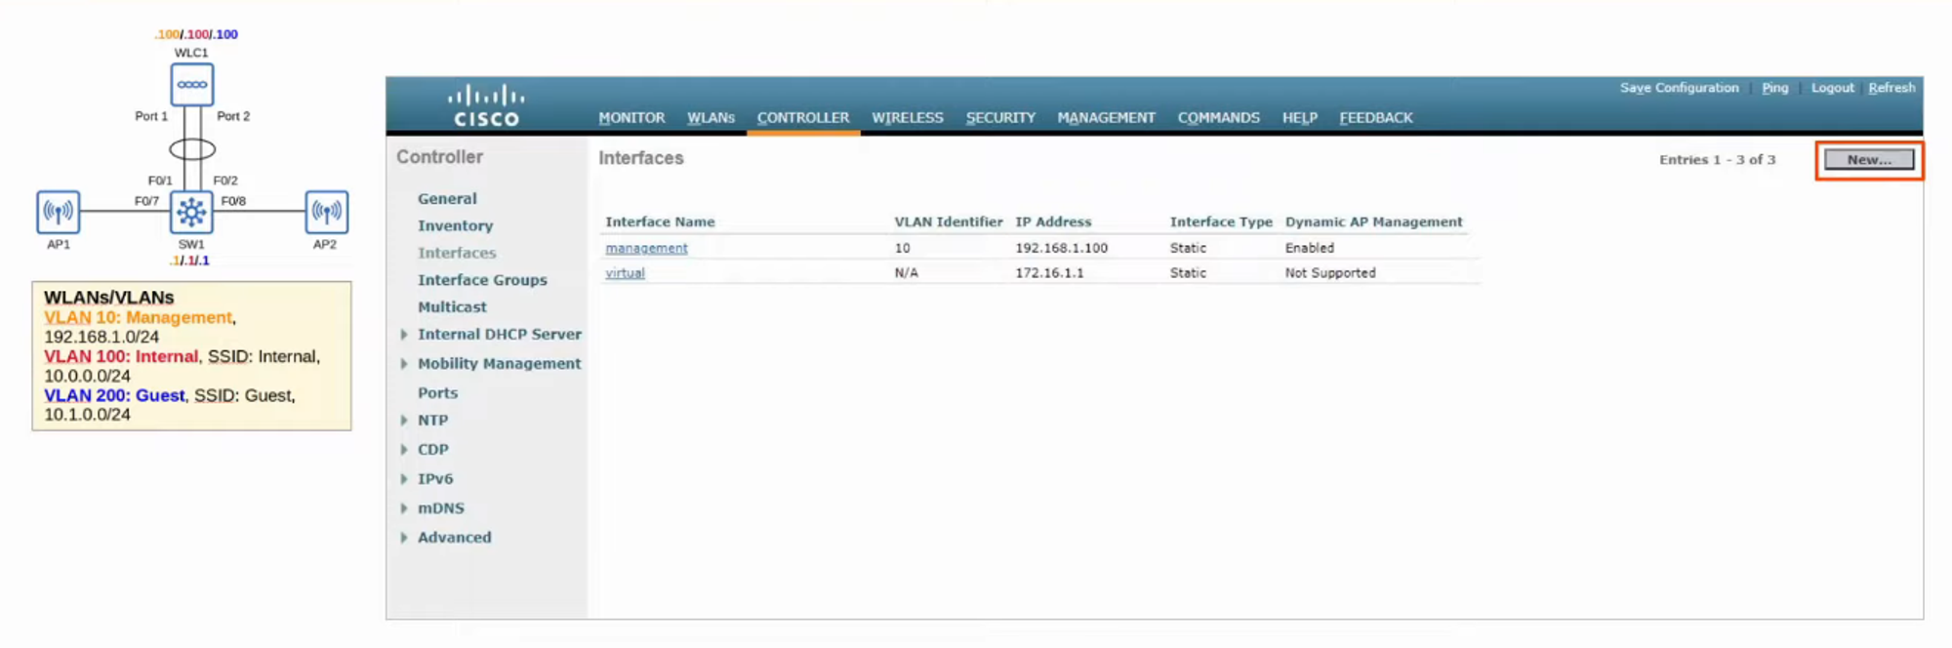

Fill in interface details and click **"APPLY"** 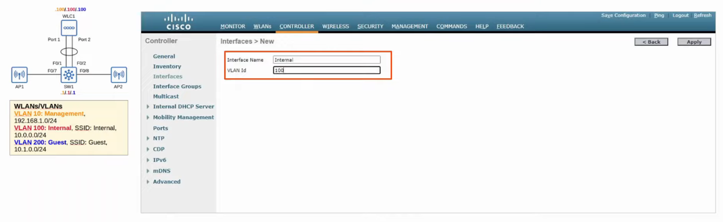

Repeat the above steps for the **Guest Interface** 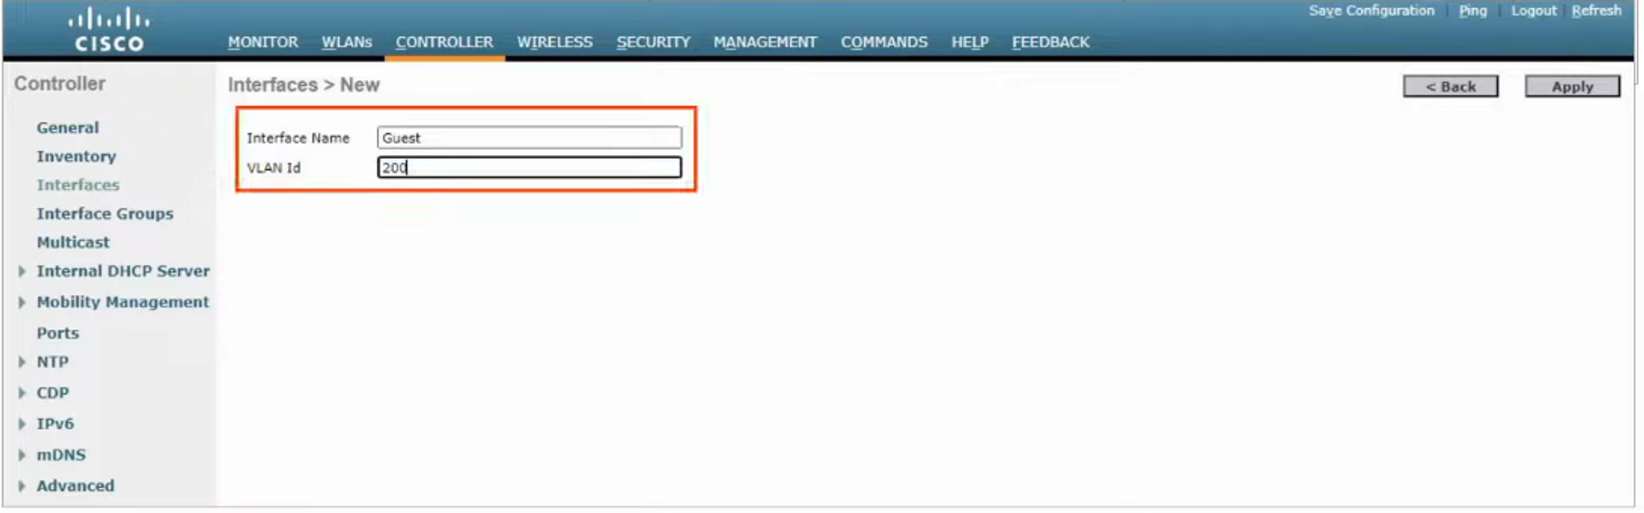

### **Security Configuration**

* Change WLAN interface to **"INTERNAL"**
* Set security from **[WPA2]** to **[WPA2 PSK]**
* Check **"Enable PSK"** box and set password 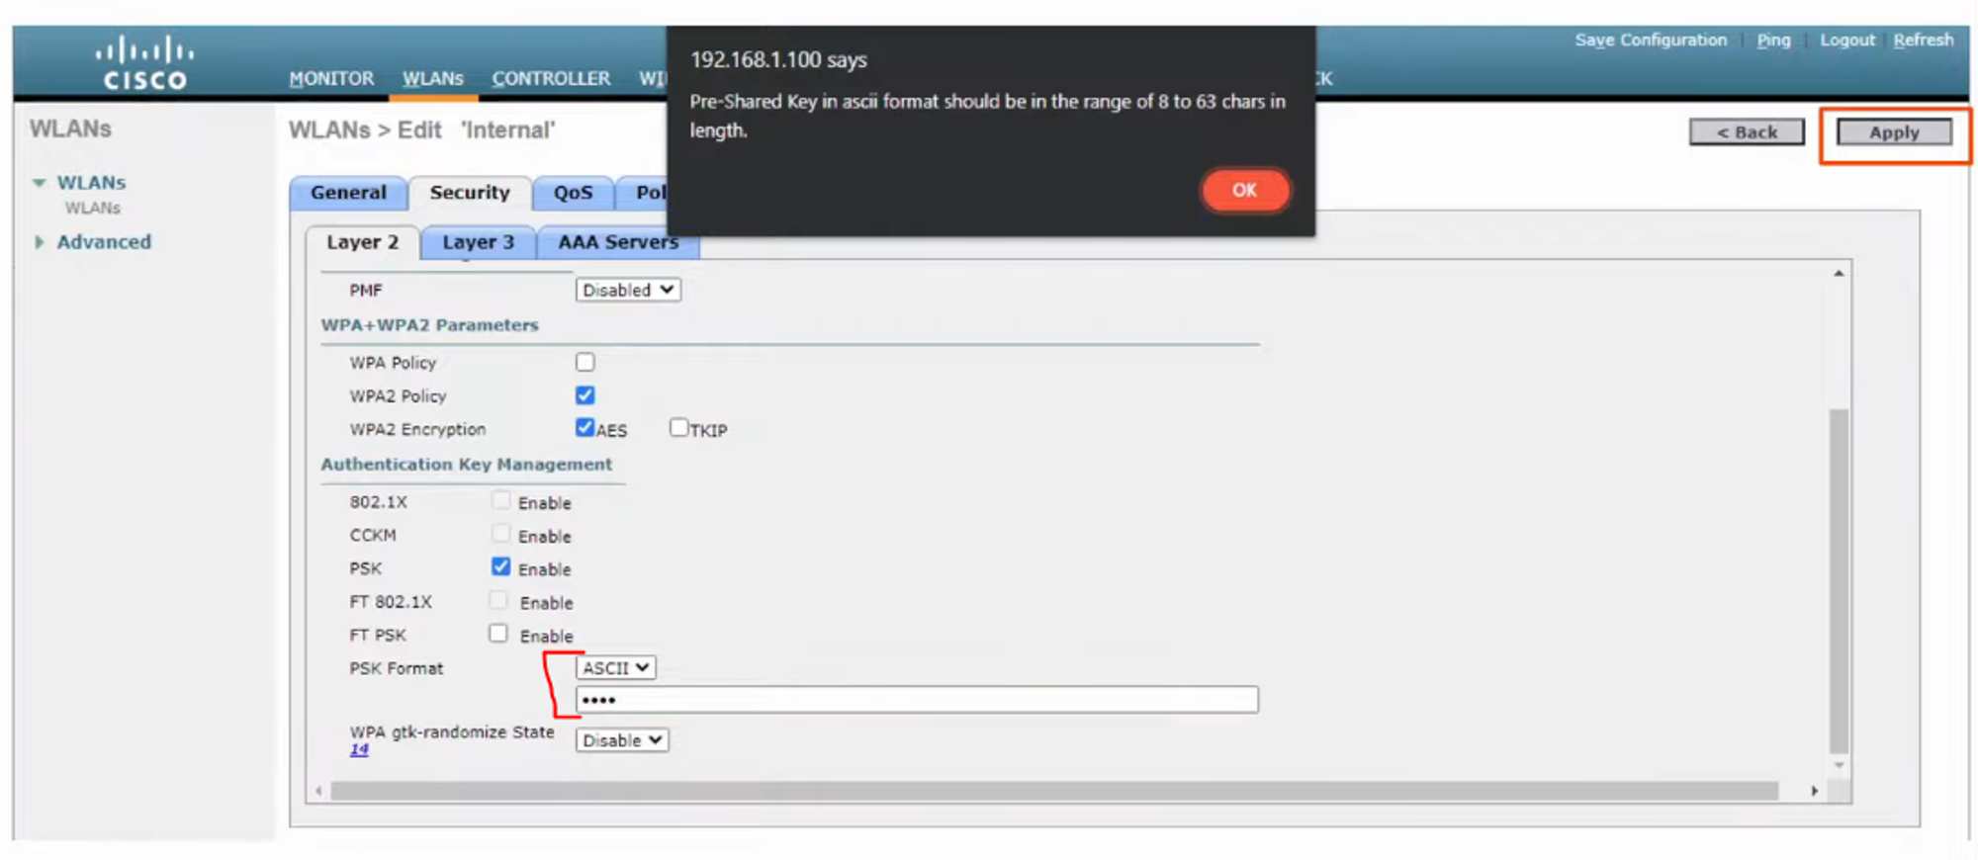

## **Web Authentication Options**

* **Web Authentication**: Users enter username & password.
* **Web Passthrough**: No credentials required; users accept terms.
* **Conditional & Splash Page Redirect**: Requires 802.1x authentication.

## **QoS Configuration**

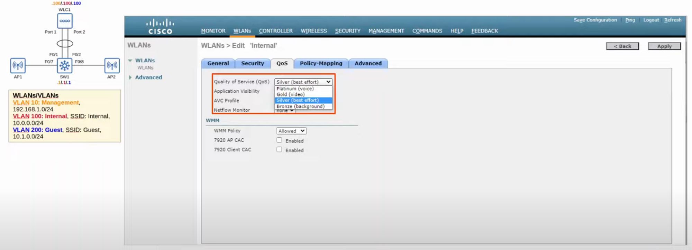

Default QoS setting is **"Silver" (Best Effort)**. Adjust as needed for different traffic classes.

## **Advanced Settings**

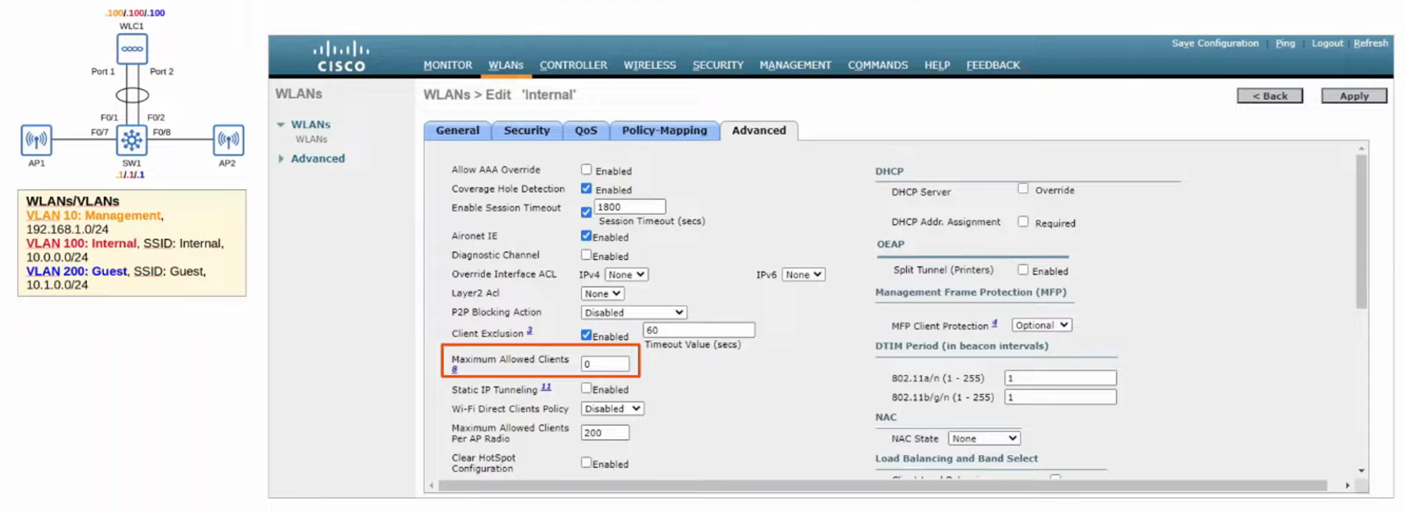

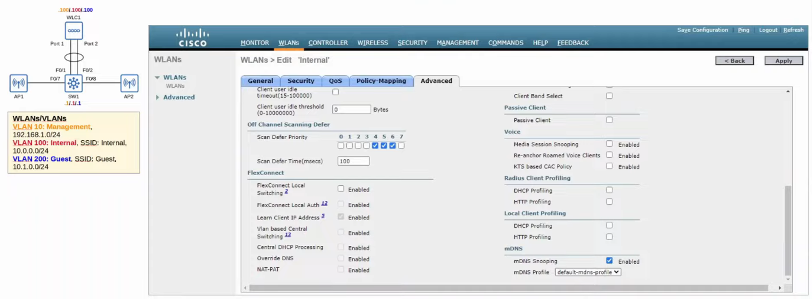

## **Configuring a New Guest WLAN**

Change **STATUS** to **"ENABLED"** 